To receive quiz feedback, go into Blackboard, select My Grades, and click on the Quiz you want feedback on:

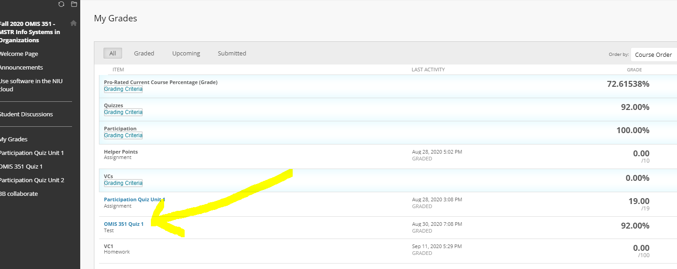

Once in there, you must click on the score of the Quiz itself (even though it’s not underlined). Once you do that, you receive full feedback.

