OMIS 259 QUIZ 7

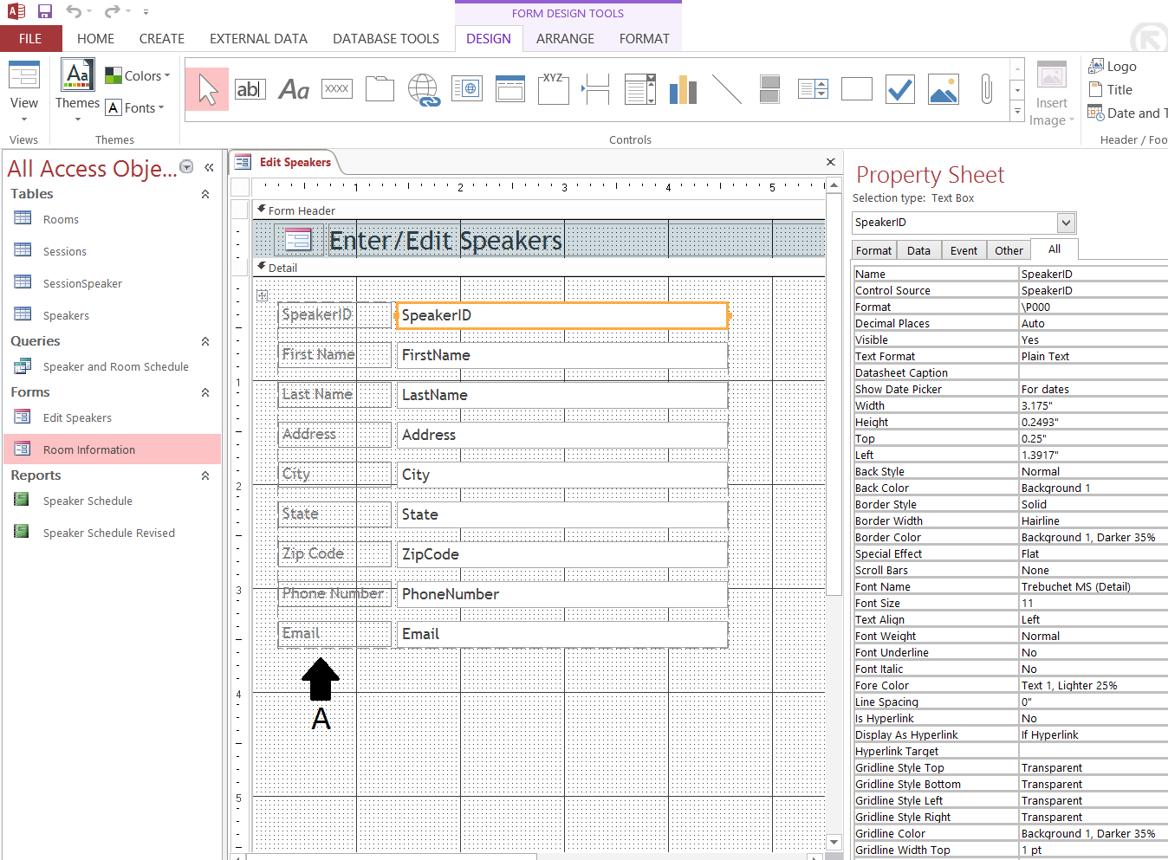
Figure 1. Access Chapter 4 Grader Project Homework

