OMIS 259 QUIZ 6

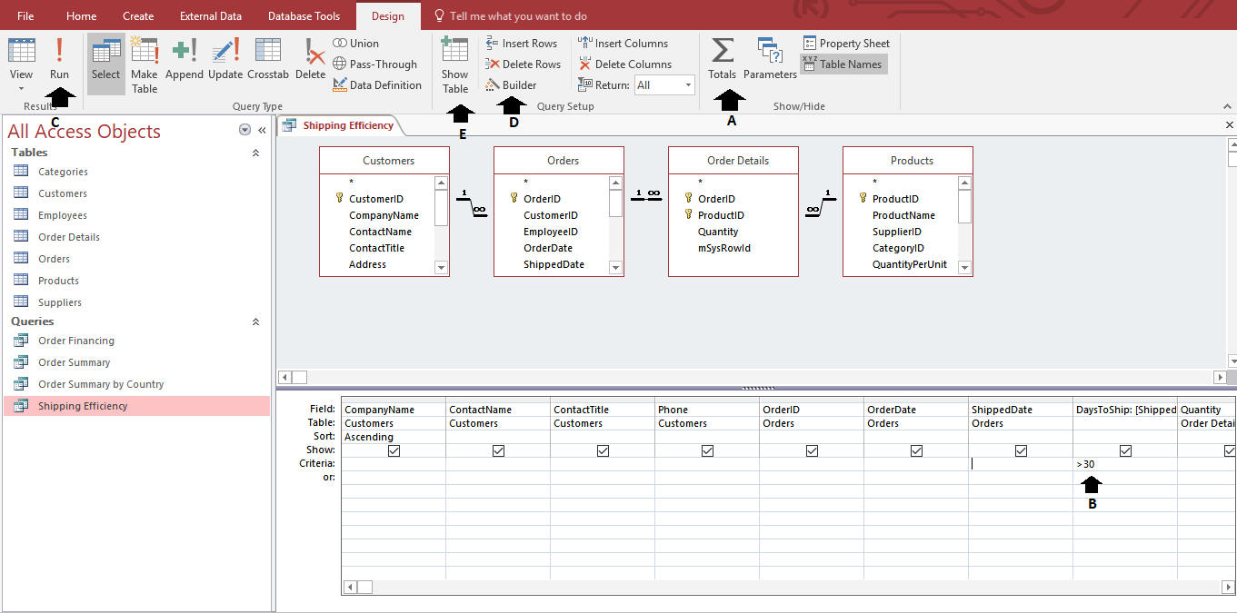

Figure 1. MyITLab: Access Chapter 3, Grader Project Homework

