OMIS 259 QUIZ 5

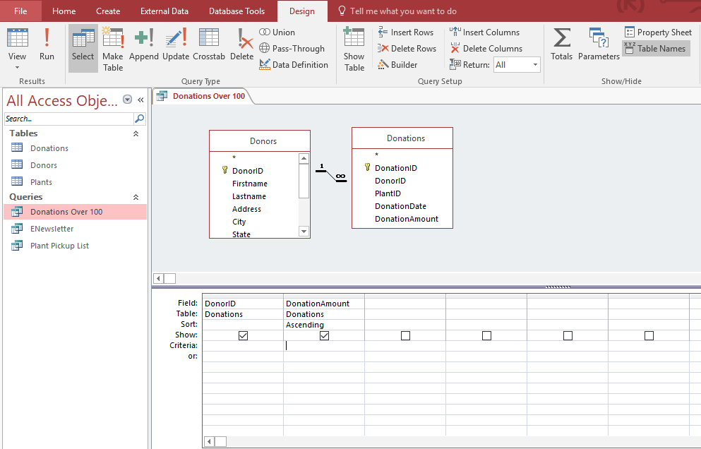

Figure 1. Access Chapter 2 Grader Project Homework

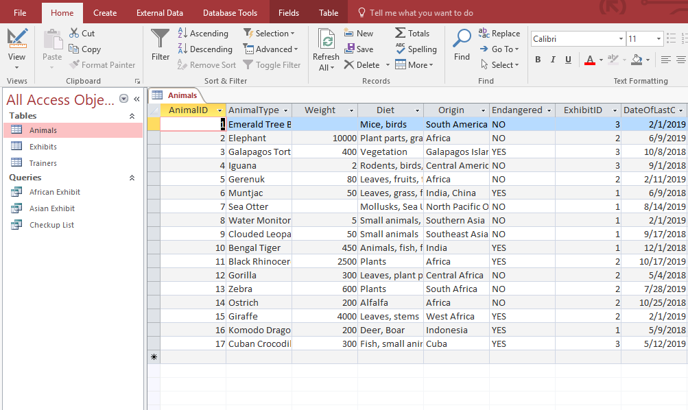

Figure 2. Access Chapter 2 Grader Project Assessment

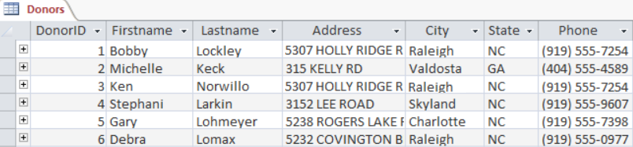
Figure 3

