OMIS 259 QUIZ 4

Fig 1.1: Chapter 4 Grader Project Homework
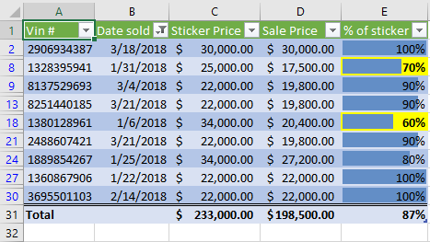

Fig 1.2: Chapter 5 Grader Project Homework 