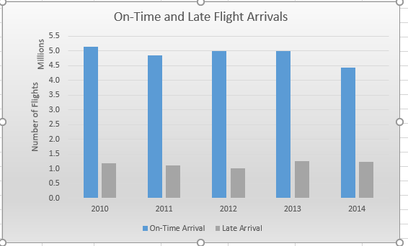

Figure1: Grader Project Homework Excel Chapter 3

