Fig 1 : Excel Chapter 2 Simulation Exam
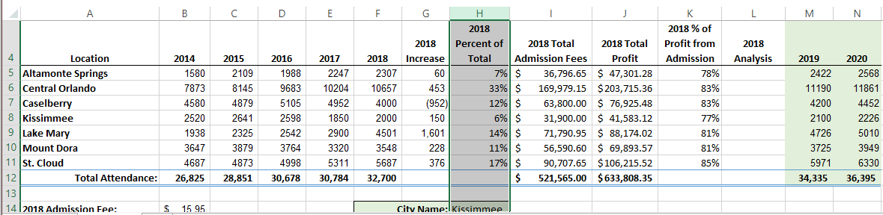

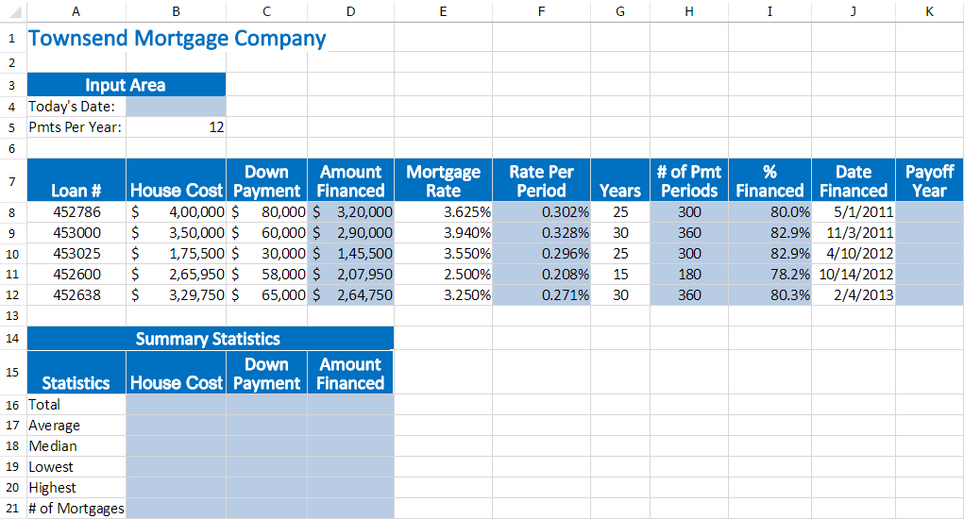
Fig 2 : Excel Chapter 2 Simulation Training

Fig 3: Grader Project Homework from Excel Chapter 2
