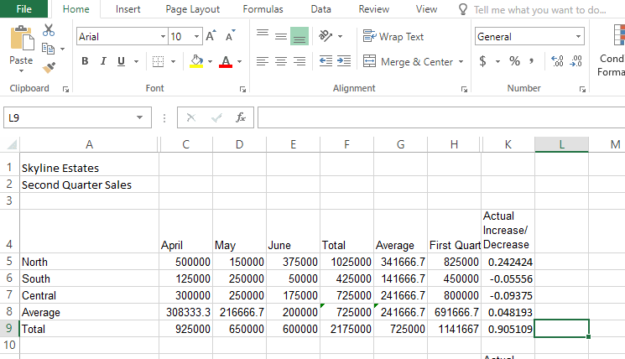
Figure 1. Simulation Exam, Excel Chapter 1

<Figure 2: Intentionally Removed>

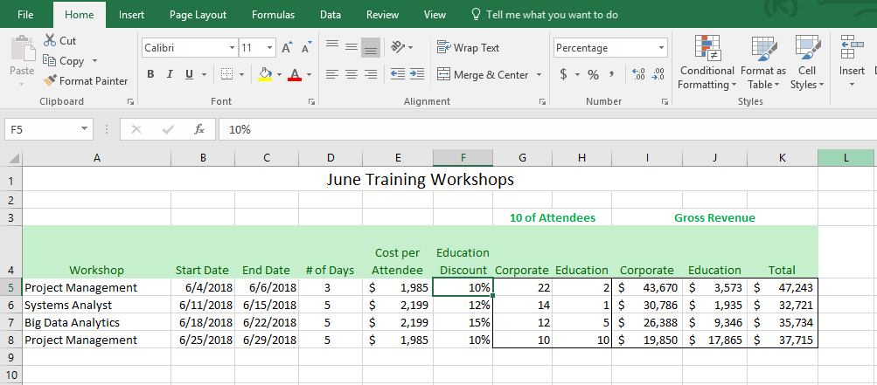
Figure 3. Grader Project Assessment, Excel Chapter 1

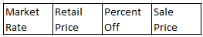
Figure 4

